Parking and Transportation to the Community Center (CC)

PARKING Near the Center
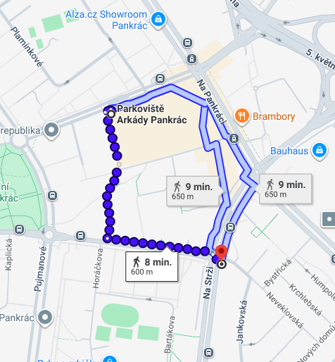

Arkády Pankrác Shopping Center
(Na Pankráci 1727/86, Praha)
- Weekdays: First 2 hours free. Each additional commenced hour costs 50 CZK/hour.
- Overnight parking: Parking outside the shopping center's opening hours is strictly prohibited.
- Weekends (7:00–22:30): FREE. (Note: The shopping center experiences high visitor traffic).
- Capacity: Approx. 1,000 spots
- https://www.arkady-pankrac.cz/parkovani/

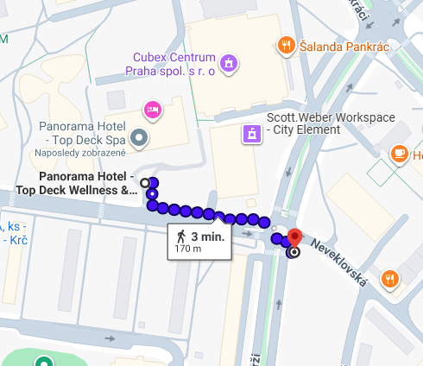
Panorama Hotel Prague Parking (Milevská 7)
- This refers to the outdoor parking lot in front of the hotel. (Do not park in the underground garages, which are reserved for office tenants).
- Distance: 3–5 min. walk from the CC.
- Rate: 60 CZK/hour
- Capacity: Approx. 300 spots

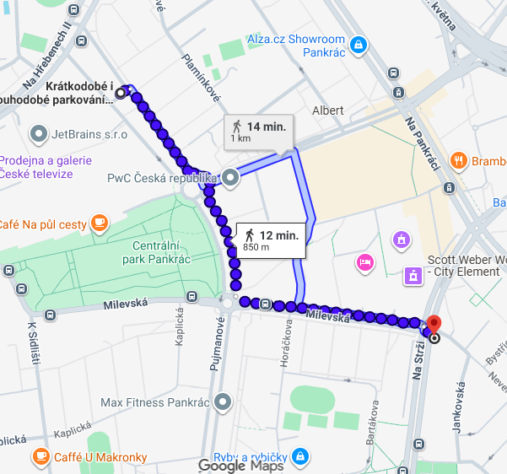
Pujmanové Parking Lot
(At the intersection of Pujmanové and Na Hřebenech II streets)
- Distance: Approx. 1 km from the CC (10–15 min. walk).
- Rates: 50 CZK/hour | 350 CZK/day | 550 CZK/2 days
- https://www.parkovani-pankrac.cz/

PARKING on the Outskirts of Prague (P+R)
(P+R = Park and Ride) – Park your car and take public transport (MHD) to the CC.
From the D1 highway (from Brno):
- Best options: Westfield Chodov shopping center (first 2 hours free, then 60 CZK/hour), P+R Chodov (50 CZK/day), P+R Opatov (50 CZK/day), or P+R Roztyly Plaza (50 CZK/day).
- All are located right next to Metro Line C stations, which takes you directly to Pankrác station (next to the CC). The metro ride from Opatov to Pankrác takes about 10 minutes.

From the D5 highway (from Plzeň):
- Best options: P+R Zličín (50 CZK/day), Westfield Zličín shopping center (Mon-Fri: first 2 hours free, then 60 CZK/hour; Sat-Sun: first 4 hours free, then 60 CZK/hour), or P+R Nové Butovice (100 CZK/day).
- Take Metro Line B to Florenc station, transfer to Line C, and get off at Pankrác. The total public transport journey from Zličín to Pankrác takes about 40 minutes.

From the D8 highway (from Ústí nad Labem):
- Best options: P+R Ládví (100 CZK/day) or P+R Letňany (50 CZK/day).
- Both are on Metro Line C, which goes directly to Pankrác station. The metro ride from Letňany to Pankrác takes about 25 minutes.

From the D10 and D11 highways (from Mladá Boleslav, Hradec Králové):
- Best options: P+R Černý Most or P+R Rajská Zahrada (both 50 CZK/day).
- Take Metro Line B to Florenc station, transfer to Line C, and get off at Pankrác. The journey from Černý Most to Pankrác takes about 35 minutes.

Traveling by Train or Bus to Prague

Main Railway Station (Hlavní nádraží): Located directly on Metro Line C. Take the metro straight to Pankrác station. The ride takes about 10 minutes.

Masaryk Railway Station (Masarykovo nádraží): Located next to Metro Line B (Náměstí Republiky station). Take Line B to Florenc, transfer to Line C, and go to Pankrác. The journey takes about 20 minutes.

Smíchov Railway Station (Smíchovské nádraží): Most trains continue to the Main Station. If you get off here, take Metro Line B to Florenc, transfer to Line C, and get off at Pankrác. The journey takes about 25 minutes.

Intercity Bus Terminals: Long-distance bus stops are located at the same major metro hubs as the P+R parking lots. The easiest way to reach the CC is to take the metro directly to Pankrác station.

Public Transport (MHD) Ticket Prices: (Note: Leave this section empty for you to fill in the exact current ticket prices, e.g., 30 min / 90 min / 24-hour passes).
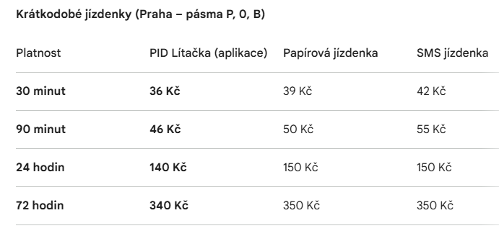

Maps
Route to the CC from Pankrác metro station (approx. 2-minute walk)
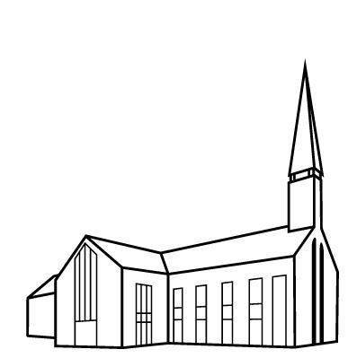

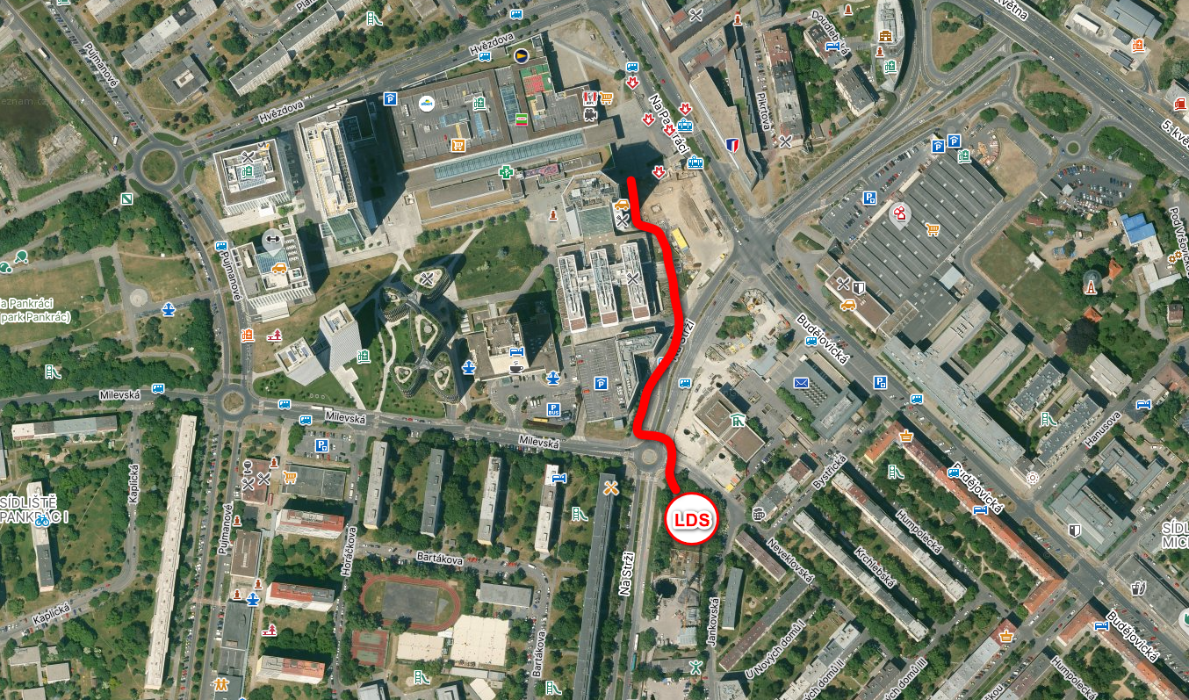

Parking locations near the CC (walking distance under 5 minutes)
